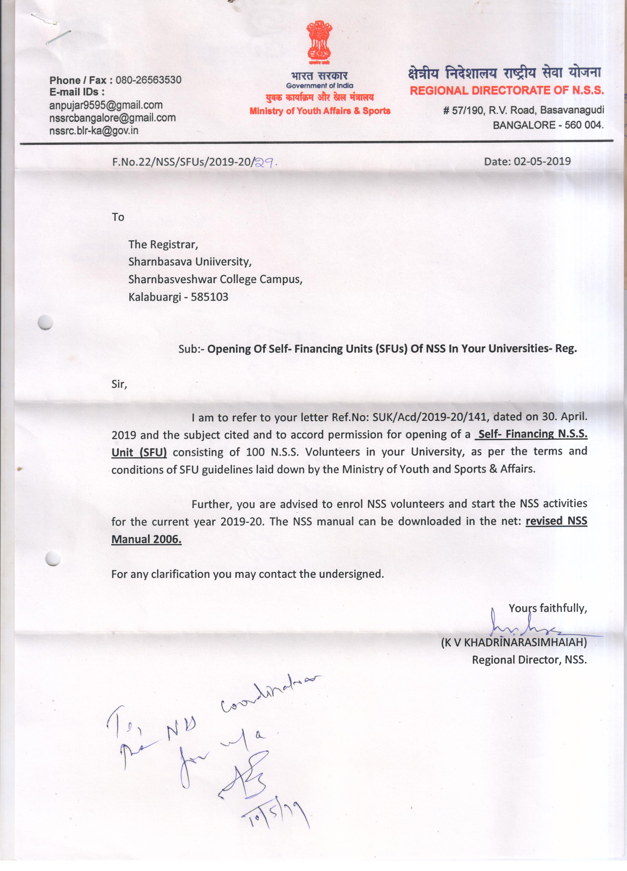
NSS VOLUNTEER LIST
SI NO | NAME | USN
1 | ABHISHEK | SG18MEC002
2 | ABHISHEK BIRADAR | SG18MEC003
3 | CHANDAN SINGH | SG18MEC007
4 | ABUBAKAR | SG18MEC008
5 | AISHARYA GOBBUR | SG18MEC009
6 | AKASH | SG18MEC013
7 | AKASH N K | SG18MEC014
8 | AMAR HIREMATH | SG18MEC015
9 | ANIL NATIKAR | SG18MEC018
10 | ANKUSH KUMBAR | SG18MEC019
11 | ANNAVEER | SG18MEC020
12 | ARUNKUMAR | SG18MEC022
13 | BASAVAYYA SALIMATH | SG18MEC026
14 | CHANNAVEER | SG18MEC028
15 | JAGADEESH GANIGER | SG18MEC036
16 | KALYAN KUMAR | SG18MEC037
17 | KARTHIK DENGI | SG18MEC039
18 | KIRAN M G | SG18MEC041
19 | MANOJ JAIN | SG18MEC053
20 | NAVEEN | SG18MEC074
21 | PRADEEP | SG18MEC081
22 | RAGHAVENDRA | SG18MEC088
23 | RAKESH G M | SG18MEC090
24 | VIKAS | SG18MEC095
25 | VISHAL L B | SG18MEC123
26 | HARSHIT S G | SG18CIV033
27 | LAXMIKANT ALOOR | SG18CIV040
28 | MOHAMMED KHIZAR | SG18CIV056
29 | MOHAMMED SOHAIL | SG18CIV059
30 | NEHAL | SG18CIV068
31 | OWAIS MUSHARAFF | SG18CIV073
32 | PARVEZ BAIG | SG18CIV074
33 | PAVANKUMAR PATIL | SG18CIV075
34 | PAVANREDDY | SG18CIV076
35` | PRAJWAL | SG18CIV080
36 | PRAMOD | SG18CIV081
37 | PRAVEEN P MALIPATIL | SG18CIV085
38 | PRAMOD | SG18CIV087
39 | PRAVEEN | SG18CIV088
40 | REVANSIDDAIAH | SG18CIV097
41 | REVANSIDDA | SG18CIV098
42 | ROHITKUMAR S K | SG18CIV101
43 | SACHIN M | SG18CIV102
44 | SADASHIVREDDY | SG18CIV103
45 | SAGAR | SG18CIV104
46 | SAGAR B SINGHE | SG18CIV106
47 | SHIVANI S | SG18CIV121
48 | SOUMYA | SG18CIV131
49 | VANITA S H | SG18CIV144
50 | VEERESH | SG18CIV146
51 | VEERESH HUDGI | SG18CIV148
52 | VINAYKUMAR | SG18CIV150
53 | MALLIKARJUN | SG18EEE022
54 | PRAVEEN M KALBURGI | SG18EEE028
55 | SYED HABEEB UR RAHMAN | SG18EEE053
56 | PRADEEP KUMAR | SG18ECE049
57 | PRATIKSHA K | SG18ECE054
58 | RAGHUVEER | SG18ECE056
59 | SADIYA SADAF | SG18ECE062
60 | SAGAR A K | SG18ECE063
61 | SAGAR G M | SG18ECE064
62 | SAMREEN ZEBA | SG18ECE065
63 | SHIVANI PATIL | SG18ECE069
64 | SHRADHA S GODI | SG18ECE071
65 | SHREYA KULKARNI | SG18ECE073
66 | SHWETA S K | SG18ECE074
67 | SHWETA M P | SG18ECE075
68 | SMITA S BIRADAR | SG18ECE076
69 | SNEHA | SG18ECE077
70 | SOUMYA B G | SG18ECE080
71 | SUSHMITA N | SG18ECE081
72 | VAISHNAVI K | SG18ECE083
73 | VIJAYLAXMI | SG18ECE084
74 | PRIYANKA | SG18ECE085
75 | VISHALAKSHI J | SG18ECE087
76 | AKSHAYKUMAR | SG18MCM001
77 | AKSHATA HOSMANI | SG18MCM002
78 | AMBRISH | SG18MCM004
79 | ARUNKUMAR J | SG18MCM005
80 | INAPPA S | SG18MCM014
81 | RAJASHEKHAR S G | SG18MCM032
82 | SANGAMESH C | SG18MCM035
83 | SHRUTI SHIVANAND | SG18MCM042
84 | YALLALING | SG18MCM056

